**Initial Case 1:**

Memory usage: 530.6171875KB

Runtime: 6 Milliseconds

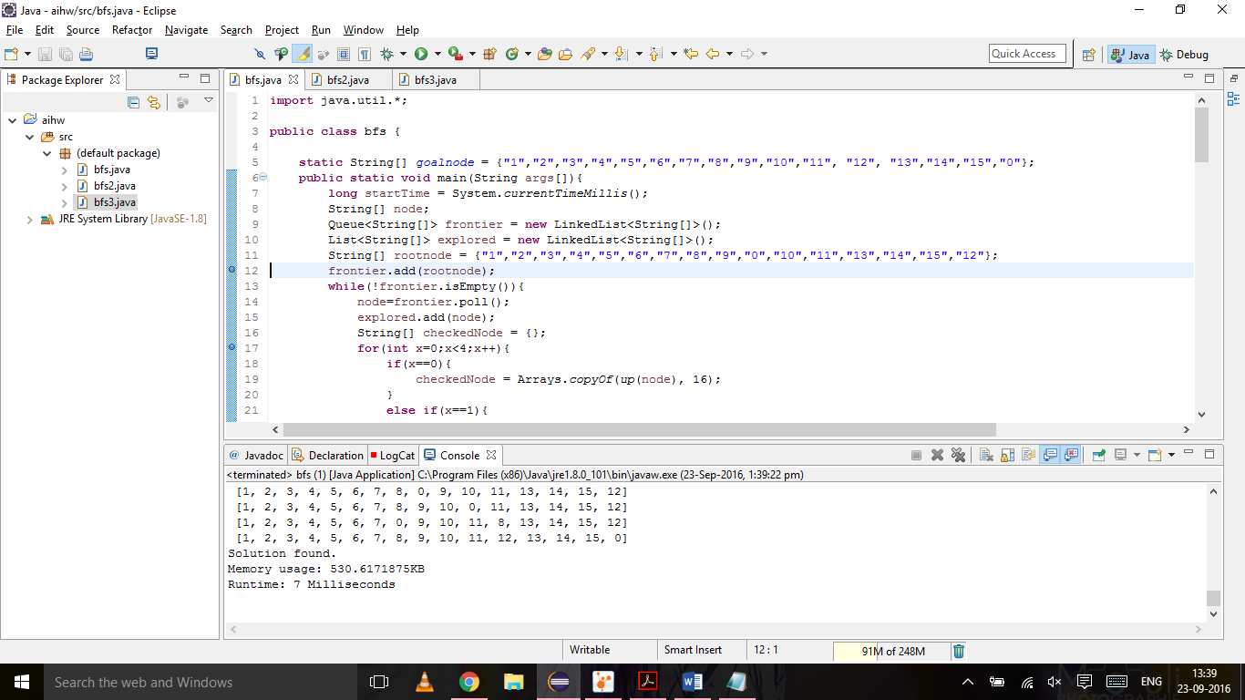

**Initial Case 2:**

Memory usage: 9605.8515625KB

Runtime: 57523 Milliseconds

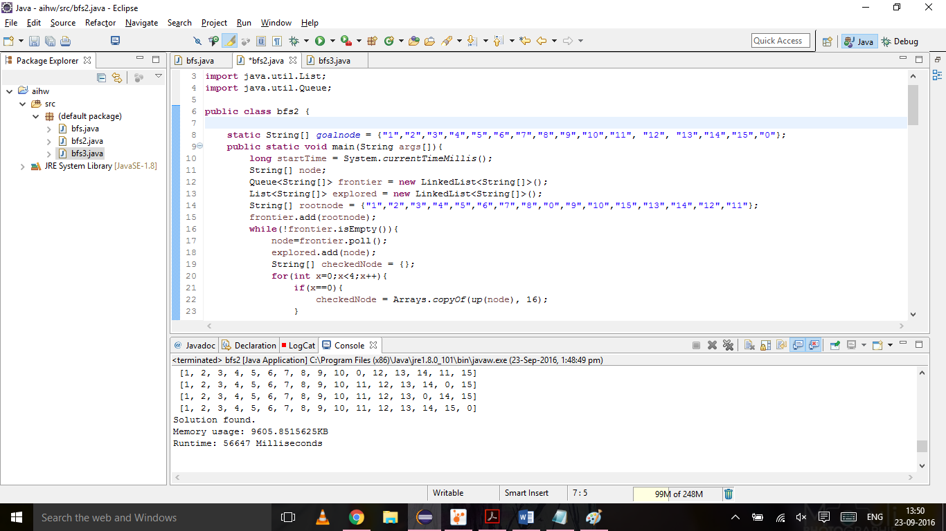

**Initial Case 3:**

Memory usage: ?

Runtime: ?

